**Lab 4 – SQL**

**Due Thursday February 18th**

**Each problem is worth one point. No partial credit will be given. This lab is worth a total of 20 points.**

**Use hostname: classdb.jccc.edu**

**From this lab forward, please notice if a result table is in a particular order. If it is you must use the order by clause. Failure to do so will result in 0 points for that specific problem.**

**Place all answers into ONE .sql file. Attach that file to the Dropbox for Lab 4 in D2L. Only one .sql file will be accepted.**

**\*\*\*\* Use the AP table space for the following questions \*\*\*\***

**1. Write an SQL statement to generate the following error message: ORA-00904. Use the**

**Invoices table.**

**2. Write an SQL statement to generate the following error message: ORA-00942. Use the**

**Invoices table.**

**3. Write an SQL statement to generate the following error message: ORA-00933. Use the**

**Invoices table.**

**4. Write an SQL statement to generate the following error message: ORA-00936. Use the**

**Invoices table.**

**5. Display formatted invoice totals as dollar amounts. Use the Invoices table.**

**Partial Result Table (114 rows total)**

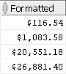

**6. Display invoice totals in scientific notation. Use the Invoices table.**

**Partial Result Table (114 rows total)**

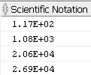

**7. Display the following result table. Use the Invoices table.**

**Partial Result Table (114 rows total)**

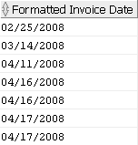

**8. Display the invoices for May 7, 2008. Use the Invoices table.**



**\*\*\*\* Use the Student table space for the following questions \*\*\*\***

**9. Display the enrollment information for students enrolling on January 30, 2007. Use the**

**Enrollment table.**

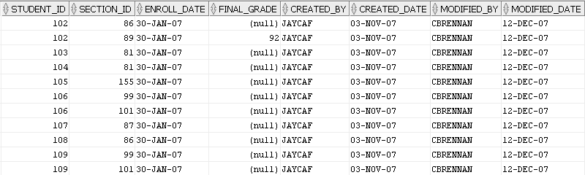

**10. Display the city, state and zip as one column. You must use the concat function to receive**

**credit. Use the Zipcode table.**

**Partial Result Table (227 rows total)**

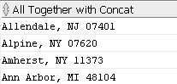

**11. Display the city, state and zip as one column. You must use ||’s to receive**

**credit. Use the Zipcode table.**

**Partial Result Table (227 rows total)**

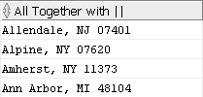

**12. Display the city in upper case, lower case and mixed case. You must use one SQL**

**statement only. Use the Zipcode table.**

**Partial Result Table (227 rows total)**

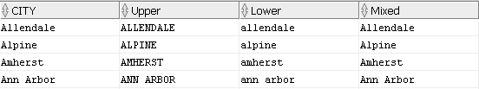

**13. Display all cities whose number of characters are between 5 and 9 inclusive. Use the**

**Zipcode table.**

**Partial Result Table (156 rows total)**

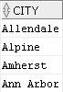

**14. Display the 2nd, 3rd and 4th character of all cities. Use the Zipcode table.**

**Partial Result Table (227 rows total)**

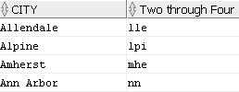

**15. Display the last 3 characters of all cities. Use the Zipcode table.**

**Partial Result Table (227 rows total)**

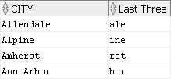

**16. Display all rows in the Grade_Summary table. For any null values in the Midterm_Grade**

**column, display 0. Use the Grade_Summary table.**

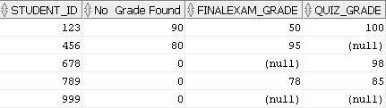

**17. Display all students that are doctors. Replace the Dr. salutation with Doctor. Use the**

**Student table.**



**18. Remove all spaces at the end of the street address. Use the Student table.**

**Partial Result Table (268 rows total)**

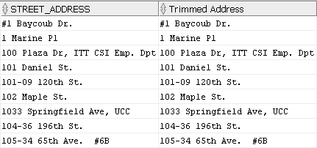

**\*\*\*\* Use the Dual table for the following questions \*\*\*\***

**19. Convert a character string to a number. Use the Dual table.**



**20. Using the SQRT function, create the following result table. Use the Dual table.**

